CRUD PROJECT BACKEND

HomeBrew

Brief

The overall objective of the project is the following:
- To create an OOP-based application with utilisation of supporting tools, methodologies and technologies that encapsulate all core modules covered during training.
More specifically, you are required to create a full-stack web application following the enterprise architecture model:
- An application back-end developed using Java (Spring Boot framework).
- A test suite utilising JUnit and Mockito for integration and unit tests of the back-end as well as Selenium for automated front-end tests
- A managed MySQL database hosted locally or within a cloud provider examined during Cloud Fundamentals module.
- A front-end developed using JavaScript, HTML and CSS.

Kanban Board
For my Kanban board I used Jira Software.
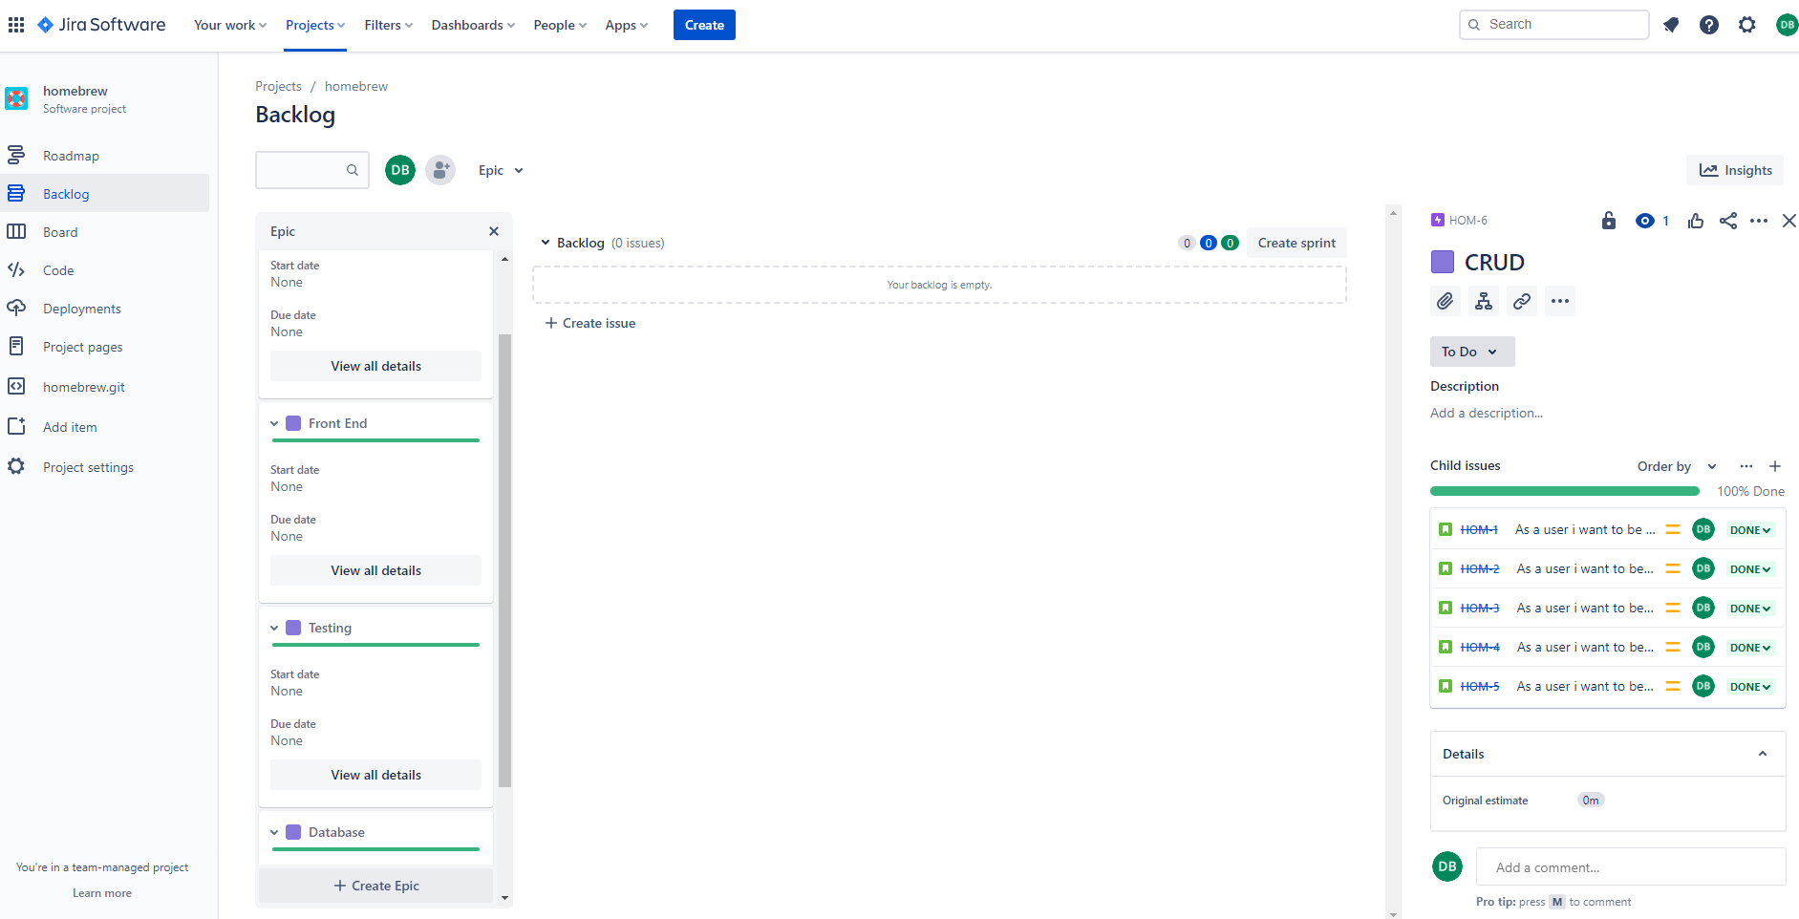

I entered several user stories and linked them with their respective Epics. I then signed each user story, story points based off of how long the task will take. I have to say, I was some way off on some of my estimations.

Database
I used a MySQL database to link with my front-end that is able to store entries and populate requests.

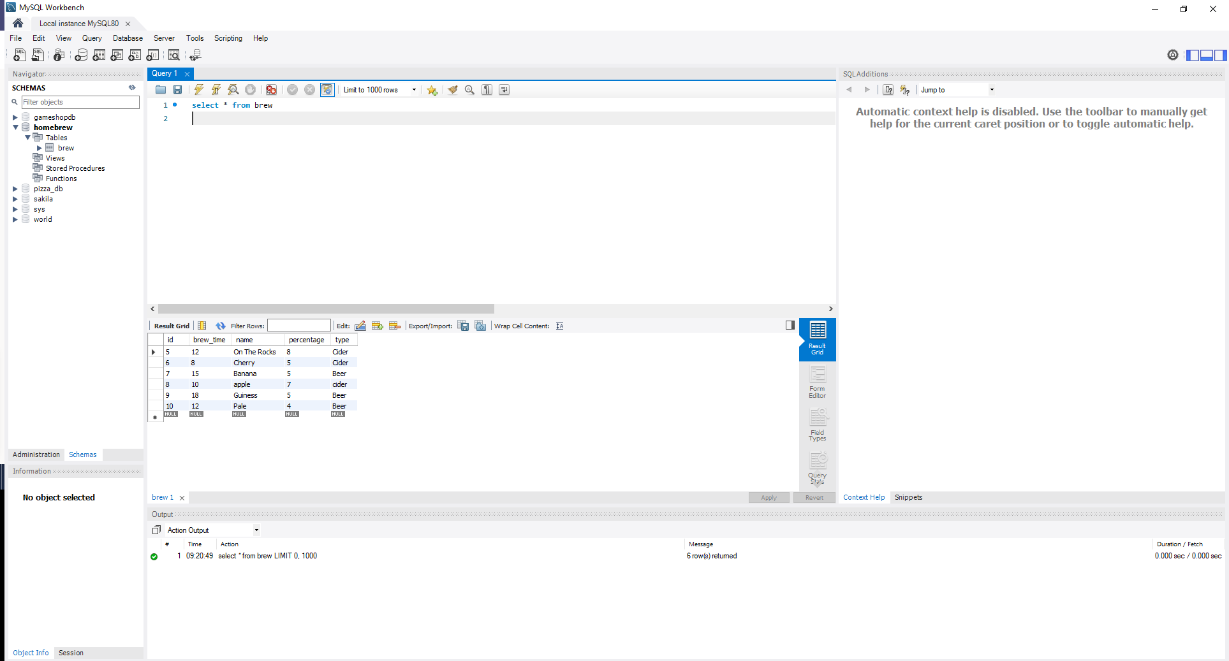
In order to properly test the back-end I used a local H2 Console.

Back-end
The back-end is written in Eclipse using Java and Spring, This was a challenging part of the project for me but Its functional. The back-end also links MySQL with the front-end.

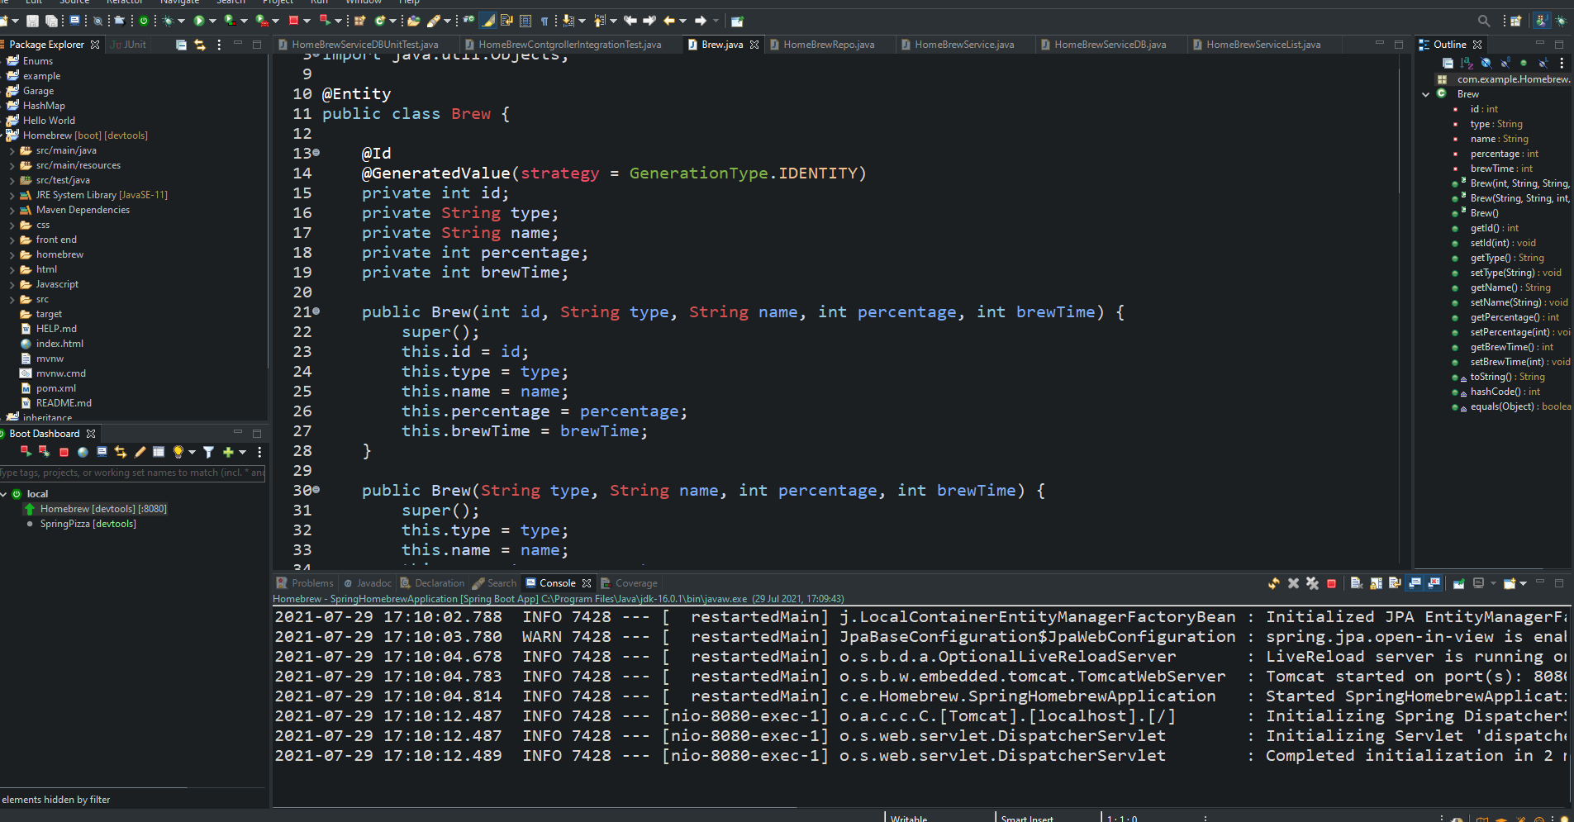
Testing
Testing is another challenging area for me, but I have created a suite Unit and Integration tests that all pass.
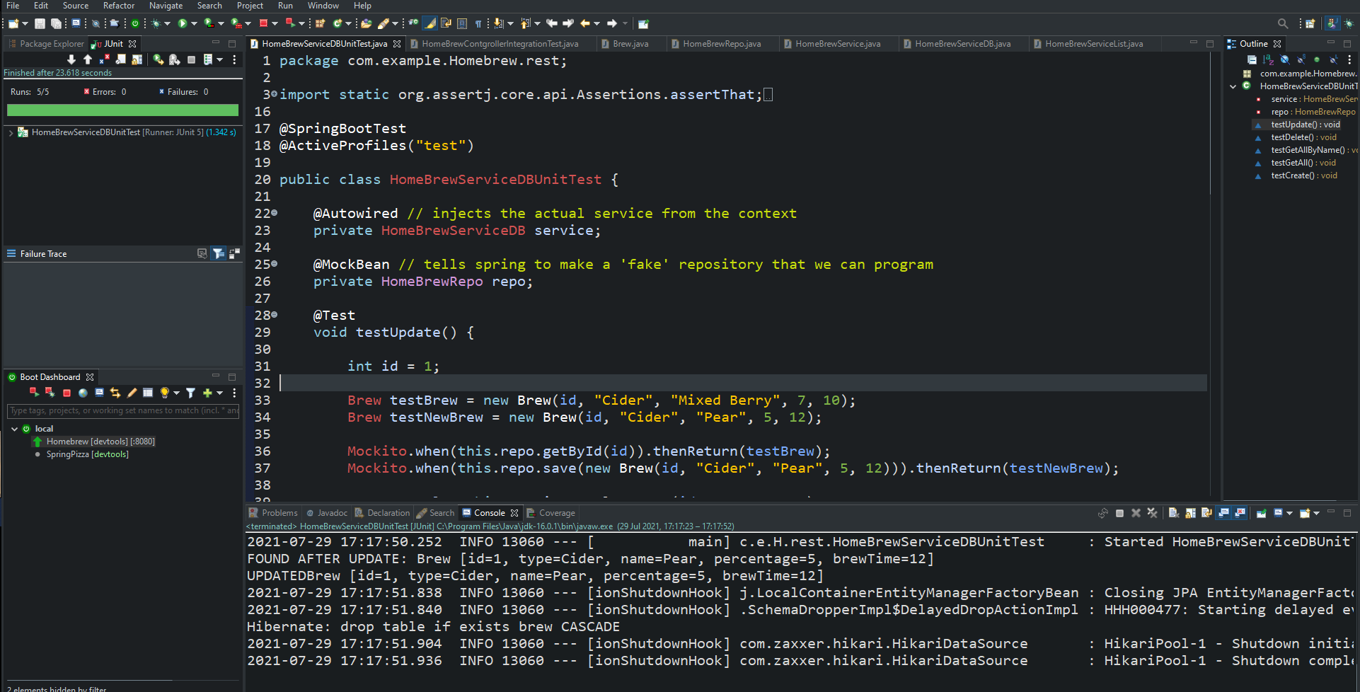

Front-end
The Front-end is written in HTML, CSS & Javascript. I also added Bootstrap later on just to help me tweak things. Javascript retrieves data from the database and creates functions. The HTML and CSS are mainly for the look and layout of the page.
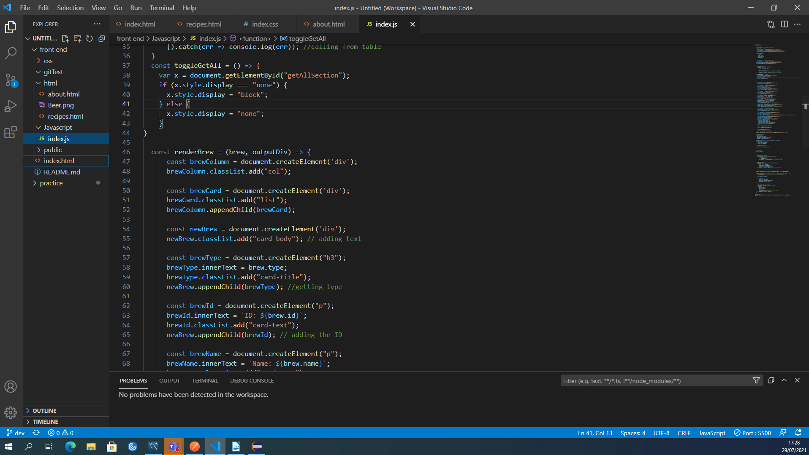

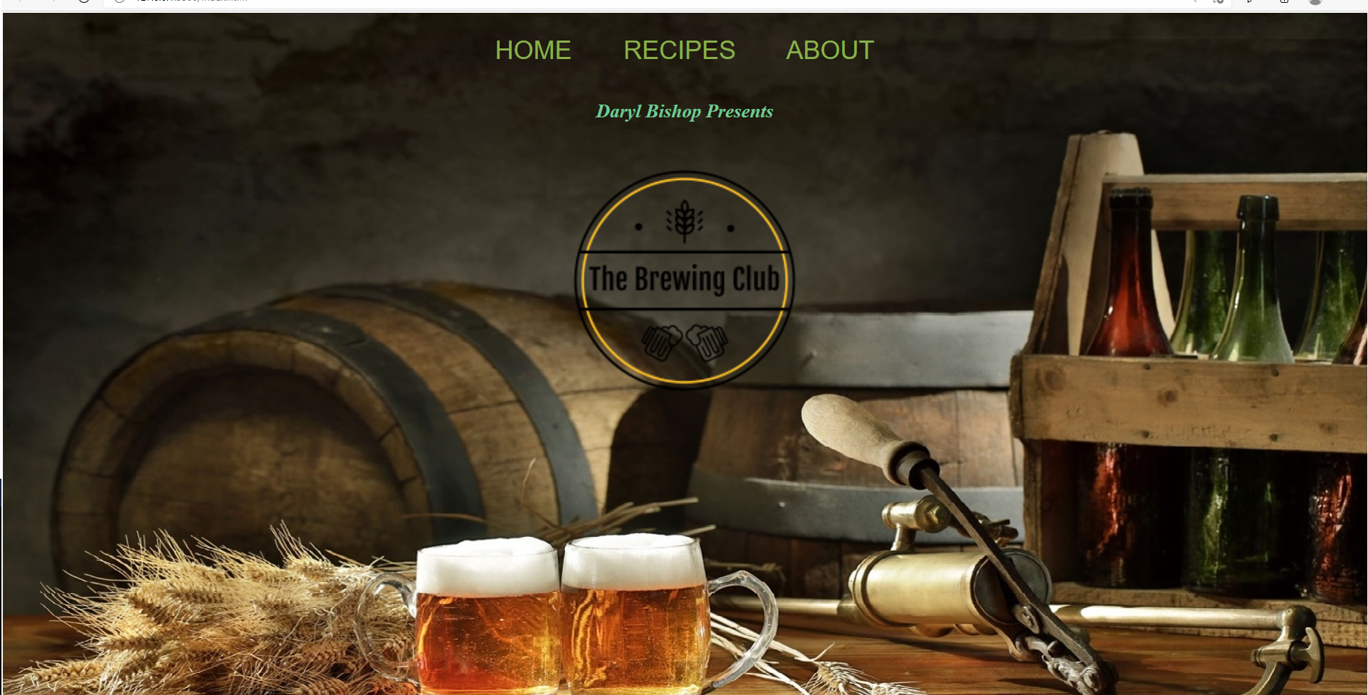

Stretch Goals
- I had hoped to have separate pages for each type of alcohol.
- Improved designing of the pages.
- Better functionality of buttons, text boxes etc.

